How Schools are Funded

Our mission is to ensure that every student has a world-class education and the resources needed to succeed. The updated budget model is designed to support DCPS’ overall mission and goal to provide equitable resources so every student can excel. DCPS’ updated budget model went into effect beginning in the 2022-2023 school year, also known as Fiscal Year 2023 (FY23). DCPS is continuing with this model for Fiscal Year 2024 for school year 2023-2024.

The DCPS School Funding Model
There were three critical factors in developing the updated funding model in 2022 for the 2022-2023 school year: transparency in funding, increasing equity for students, and year-over-year stability in school budgets.
Funds are distributed to a school based on its student and staff projections, with additional targeted support provided for students with greater need, while ensuring that schools are provided stability during year-over-year enrollment transitions. ​
- Overview
- Understanding Funding Flexibilities and Fund Sources
- Grant Funds Allocated to School Budget
Categories Of Funding Allocations
- Student Based Funds
- Staffing Ratio Allocations
- Program Grant Allocations including At-Risk funding.
- Stability Funding (Including One-Time FY24 Stability Funding)
Budget Inputs
- Average Position Cost – DCPS budgets based on an average position cost
- Enrollment Projection Methodology – Enrollment is a driver of initial budget allocations

DCPS School Funding Model Overview
The Basics
DCPS strives to be good stewards of the funding we receive through the UPSFF to ensure every student has what they need to succeed. The DCPS School Funding Model combines the strengths of a staff-based funding model and student-based funding model to ensure that all schools have the flexibility needed to provide equitable learning opportunities aligned to their students’ needs.
Any changes to the school funding model in FY24 are rooted in DCPS’ goal to ensure excellence for every student. By shifting our resources to keep students and their needs first, our schools will be able to better align their funds to meet the individual needs of the students they serve.
How Funding Is Allocated
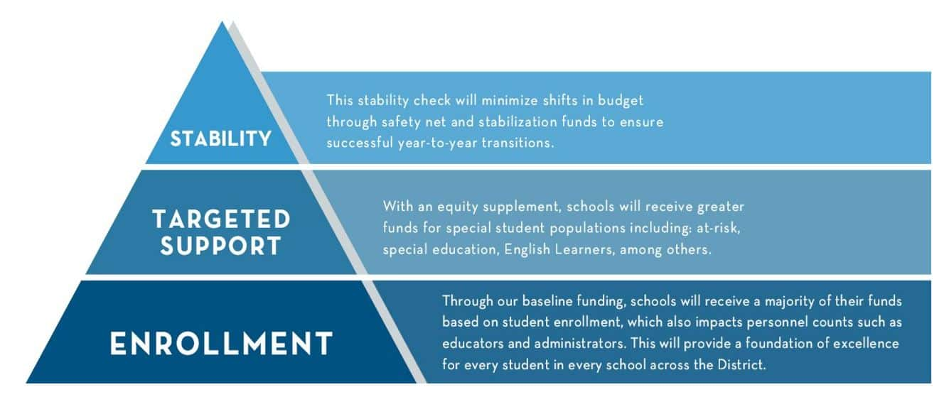
Within enrollment based, targeted support, and stability, funding will be provided to schools in four different categories. This page briefly outlines the four categories below. For a deeper dive, go to “Categories of Funding Allocations” to read more details about the DCPS funding methodology.
Student Based Funds
Student-based funds are based on the projected student enrollment count for the upcoming school year. This count is determined using historical enrollment data and factors that affect enrollment including new housing developments, new schools, and grade level matriculation and feeder patterns. Student-based funds follow the student and provide schools with a base amount for each student and additional student need weights that provide targeted per pupil funding for English learners, students with IEPs and other student categories.

Staffing Ratio Allocations
In addition to student-based dollars, the updated budget model also includes funding allocations based on staff and faculty counts. These staffing ratios ensure that essential services and instruction, such as Special Education and English language instruction, are resourced to schools that need these educators and staff most. Staffing ratio allocations do not include direct allocations of general education teachers as schools receive funding for those teachers through their student-based fund allocation.

Program Grant Allocations
The budget model also includes funding allocations through program grants for schools according to grade-level served at each school, specific programming offered, programming that supports students with greater needs. A key program grant that DCPS schools will receive is at-risk dollars to support student populations who are identified as at-risk.

Stability Funding Allocations
As DC Public Schools continue to experience shifts in enrollment, it is important that our budget model effectively supports schools of all sizes. The DCPS School Funding Model was designed to provide schools with year-over-year stability funds, with safety net checks and stabilization dollars that will protect school budgets from the impact of fluctuating enrollment and ensure that schools can afford a baseline level of general education services with their student-based funds. The Safety Net is a permanent component of the school funding model.
DCPS will continue to stabilize schools at 95% of their previous year submitted budget. Additionally, DCPS is leveraging Mayor’s Recovery Funding to further stabilize schools to their FY23 submitted budgets including one-time funding provided through FY23 Mayor’s Recovery and Hold Harmless funds.

Understanding Flexibility Levels and Fund Sources
Overview
To maintain transparency in how allocations are funded and how flexible they are, the initial allocation worksheet displays the fund source and flexibility level of each allocation. The fund source relates to how the district receives the funds, and the flexibility level relates to how much autonomy principals have in budgeting those funds. Below are definitions of the fund sources and levels of flexibility to help understand the initial budget allocation worksheet.
Fund Sources On The FY24 Initial Budget Allocation Worksheets
Local – These allocations are funded by local dollars from the city’s UPSFF. Some are fully locked (L1) due to programmatic or legal requirements or because they are part of a Memorandum of Understanding (MOU). Additionally, some allocations in this fund source are pre-budgeted (L2) and fully flexible (L3) allocations.
English Learner Uniform Per Student Funding Formula (EL UPSFF)* – This fund source contains allocations provided to schools through the city’s UPSFF. Per D.C. Act 24-176, DCPS must have a separate funding source for the elementary and secondary ELL student weight.
At-Risk* – This fund source contains allocations provided to schools through the city’s Uniform Per Student Funding Formula (UPSFF). Per D.C. Act 24-176, DCPS must have a separate funding source for at-risk students and at-risk high school overage supplement. The additional Council at-risk concentration funding allocation will also be coded under “At-Risk” fund source, but there will be two separate allocation line items to denote which is the UPSFF amount and which is the additional concentration. Note that the DCPS at-risk concentration weight part of Student Based funds is locally funded and not funded through at-risk dollars.
Title I – Title I schoolwide funds are a combination of Title I and Title II funds at Title I schools and are budgeted in support of Title I students at the school. Title I parental involvement funds are fully locked.
Title II – These allocations are funded by Title II and cannot be repurposed during the budget development process.
Department of Defense (DoD) – These allocations are funded by a cost sharing agreement with the Department of Defense and cannot be repurposed during the budget development process.
21st Century/Local – Allocations for afterschool programming at participating title I elementary and education campuses are loaded here. These allocations are funded by the 21st Century Grant and cannot be repurposed outside of afterschool programming during budget development.
Stabilization – Schools that received stability funding in the form of stabilization will find those dollars here
Mayor’s Recovery Funds –These are local dollars provided to ensure that schools maintain at least 95% of their FY23 funding level including one-time funds. Schools that received Mayor’s Recovery Funds will find those dollars here.
*Information about the EL UPSFF and At-Risk tracking requirements can be found on page 84: https://lims.dccouncil.us/downloads/LIMS/47312/Signed_Act/B24-0285-Signed_Act.pdf
Levels Of Flexibility
The updated budget model provides funding to schools for positions, programs, and non-personnel dollars. Each allocation is designated a level of flexibility (1-3) that determines principal autonomy over budgeting the allocation., programs, and non-personnel dollars. Each allocation is designated a level of flexibility (1-3) that determines principal autonomy over budgeting the allocation.
There are no changes to flexibility levels from FY23 to FY24.
See the definitions below:
Level 1 Required – Locked – These allocations are unable to be changed. This may be determined by fund source requirements and allowability, such as grants and Memorandums of Understanding (MOUs), legal requirements, and other core operational considerations.
Level 2 Required – Rarely flexible – Any shift in the allocation will maintain the intended purpose of the original allocation. Principals must demonstrate how they will meet related programmatic requirements.
Level 3 Flexible – These allocations are provided to schools to budget for staff and programming.
Exercising Flexibility over Allocations: Changes made to Level 2 allocations will be reviewed holistically by Instructional Superintendents and Program Teams to ensure all requirements all still met.

FY24 Grant Funds Allocated to School Budgets
Some grant funds are loaded directly onto school budgets and fund personnel (positions) or non-personnel (supplies, equipment, etc.) dollars.
21st Century Community Learning Center (CLC): Access to Enrichment Outside of Traditional Learning Hours
These grant funds support afterschool programs in Title I elementary or K-8 schools. This grant aims to achieve specific student outcomes related to attendance, academics, behavior improvement, family engagement, and partner engagement. The program is evaluated annually by an external evaluator.
Schools that participate in the program receive a combination of grant and local funds to hire teachers and aides to support a certain number of seats in the afterschool program.
To learn more about DCPS’ afterschool programs, click here.
Junior Reserve Officers’ Training Corps (JROTC): Supports High School Student Participation in their School’s JROTC Program
DCPS high schools with JROTC programs allocate funds towards JROTC instructors and are reimbursed 50% of the cost of the instructors though a cost sharing agreement with the Department of Defense. To learn more about DCPS’ JROTC, click here.
Title I: Improving the Academic Achievement of the Disadvantaged
These funds provide financial assistance to schools with 35% or more of children from low-income families to help ensure that all children meet challenging state academic standards. ​ Only Title I schools receive Title I dollars, and the funding is allocated as a supplement on top of the local funding allocation. Title I dollars are loaded in multiple ways, as outlined below.
- Title I Instructional funds are supplemental to schools’ local funding and are allocated on a per-pupil basis based on the school’s poverty enrollment. Title I schools receive an allocation of Title I funding based on the Eligibility Percentage (the Identified Student Percentage multiplied by 1.6 as determined by the United States Department of Agriculture (USDA)) and the actual Free and Reduced Meal (FARM) data. This methodology ensures that there is an accurate and proportionate allocation for each Title I school based on the number of low-income students served.
  - Understanding the Initial Budget Allocation Worksheet: Title I Schools Only – On the initial allocation worksheet, there is an allocation line called “Title I Schoolwide Funds.” This line is inclusive of a school’s Title I instructional allocation amount and the proportion of Title II funds generated for the respective school. (See below for background on Title II.) This total allocation amount is fully flexible.
- Title I Parental & Family Engagement funding for DCPS is 1% of the District’s total Title I allocation. This allocation is distributed exclusively to Title I schools on a per-pupil basis based on the school’s poverty enrollment. The funds are supplemental to the school’s local funding and must be used to support family engagement initiatives.
- Title I funded programs (e.g., Twilight and Ninth Grade Academies) funding are allocated year over year based on programmatic needs and available funding.
  - Twilight Programming takes place at Title I high schools and provides students who need to make up original credit an opportunity to take classes concurrently with their daytime course load. Allocations to schools are based on historical and predicted seat hours and student need. Twilight often serves students who have transferred districts or have had major disruptions to education as courses are original credit and not after a course failure.
  - Ninth Grade Academies are present at select Title I High Schools to support the ninth-grade cohort in their transition to high school. Academies are allocated an Assistant Principal and receive administrative premium and an amount of non-personnel dollars to support the cohort.
Title II: Preparing, Training, and Recruiting High Quality Teachers and Principals
These funds are intended to increase student academic achievement consistent with challenging state academic standards; improve the quality and effectiveness of educators; increase the number of educators who are effective in improving student academic achievement in schools; and provide low-income and minority students greater access to effective educators.
- Title II dollars are allocated to both Title I and non-Title I schools. Title II funds are supplemental to schools’ local funding and are allocated to each school at $25 per pupil enrolled.
- Understanding Title II Dollars and the Initial Budget Allocation Worksheet
  - At Title I schools: To increase flexibility for schools in using Title I and II funds, DCPS transfers the school’s Title II allocation into Title I schoolwide funds, which also includes the Title I Instructional allocation. As a result, Title I schools do not have an allocation line specifically for Title II funding, as these funds are included as part of the Title I Schoolwide Funds.
  - At Non-Title I schools: Title II funds are allocated for Title II allowable uses, such as professional development. Schools will see a specific allocation line for Title II funding
ESSER II Acceleration Funds
Purpose: In SY21-22 (FY22), schools received $26M in ESSER II to support a strong return to school. The funds were allocated across all schools based on school size, percent of student population identified as “at risk,” and grade bands served. Schools were required to use a portion of the funds to support Acceleration Academies and High Impact Tutoring; the remaining funds could be used flexibly to support a strong return to school (e.g., custodial supplies, classroom materials). ESSER II funds expire on 9/30/2023.
ESSER III Acceleration Funds
Purpose: For FY23 and FY24, all schools were able to request ESSER III to continue to support evidence-based acceleration programming in alignment with ESSER III’s requirement for LEAs to “address learning loss through the implementation of evidence-based interventions and ensure that those interventions respond to students’ social, emotional, and academic needs and address the disproportionate impact of COVID-19 on underrepresented student subgroups through evidence-based acceleration strategies.”
How did schools apply: School leaders were all given the opportunity to submit requests detailing how they intended to use their requested funds for the following fiscal year. DCPS Central Office reviewed and approved requests that were then sent back to schools for them to implement their acceleration strategies. For FY23, 85 schools received a total of $6.07M in FY23 ESSER III funds. For FY24, 102 schools received a total of $7M in FY24 ESSER III funds. All schools that requested funds both years were provided funds.

Student Based Funds
The Basics
Each school begins with an expected student enrollment count for the upcoming year. This is an estimated number of students by grade as well as students who receive special education and other services. Schools will receive additional funds to support students with greater needs. Schools that serve special student populations will receive additional dollars to support those students’ needs, which include services for English Learners (EL), Special Education (SPED), Pre-K and at-risk students. With a focus on school enrollment, the updated budget model provides a strong foundation for every student in every school across the District.
Below is an example of two different students in DCPS. Ella attends general education classes and does not need additional academic or language support. Mark attends general education classes and receives special education and English-language services. This image shows how the intention behind student based funds: schools receive funding based on student need. Since DCPS budgets based on projection, schools receive dollar amounts based on the projected numbers of students for each category with a weight.
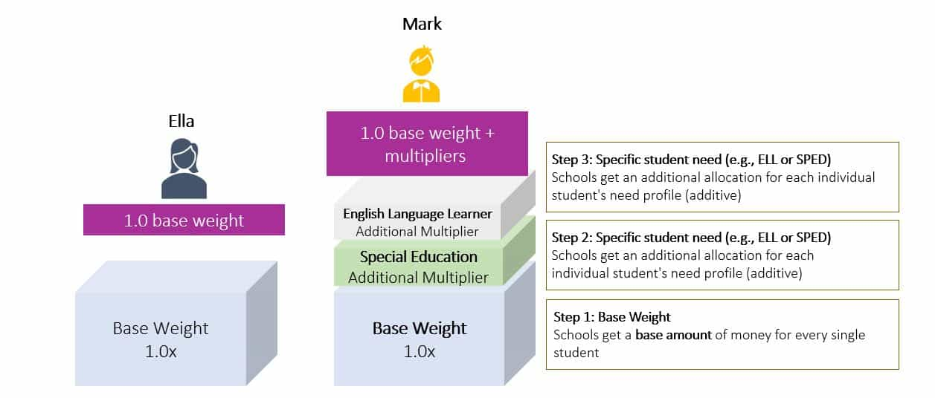
DCPS School Funding Model Student Based Weights
Below is a chart outlining the base weight and supplemental weights in the Student Based Budgeting (SBB) portion of the funding model for FY24. As displayed above, weights are additive thus the per student funding amount of a specific student will vary based on the multiple categories they may fall into.
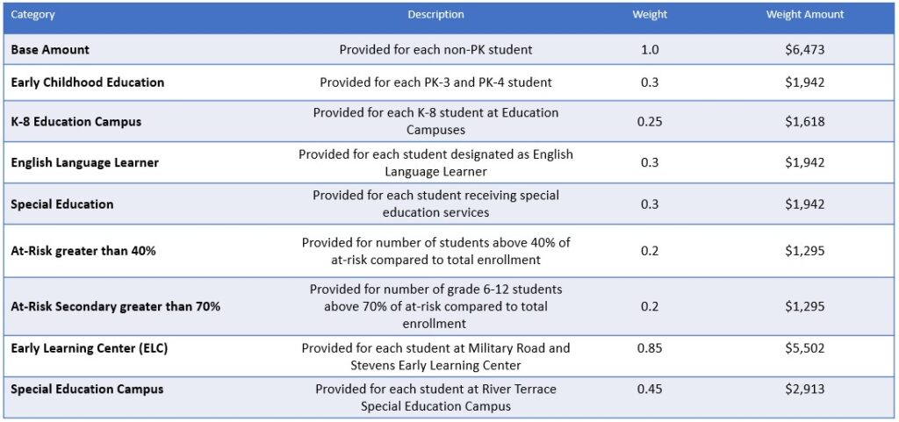
To understand the amount of a school’s student-based budgeting allocation by supplemental weight type, review this equation below.
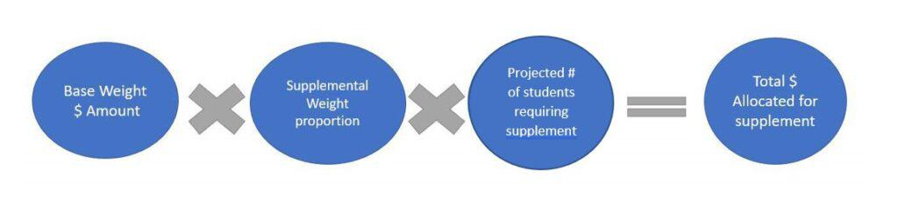
For example, for a K-8 Education Campus with 300 K-8 students, $485,400 of their Student Based Funds will be from the Education Campus weight. This was calculated by multiplying the base amount ($6,473) by the EC weight (0.25) by the number of students who are included in that group (300). In the case of the K-8 Education Campus, the students part of the group (300). In the case of the K-8 Education Campus, the students part of the group is the entire school. However, for English Learners the number of students will just be those identified as English Learners, and for 40% the at-risk concentration weight it will be for the student count once the 40% threshold is reached.

Staffing Ratio Allocations
The Basics
In addition to student-based dollars, the updated budget model also includes funding allocations based on staff and faculty counts. These staffing ratios ensure that essential services and instruction, such as special education and English language instruction, are resourced to schools that need these educators and staff most.

Staffing Allocations In The Updated Budget Model
Below is a chart outlining the staffing allocations provided to schools in the FY24 DCPS School Funding Model
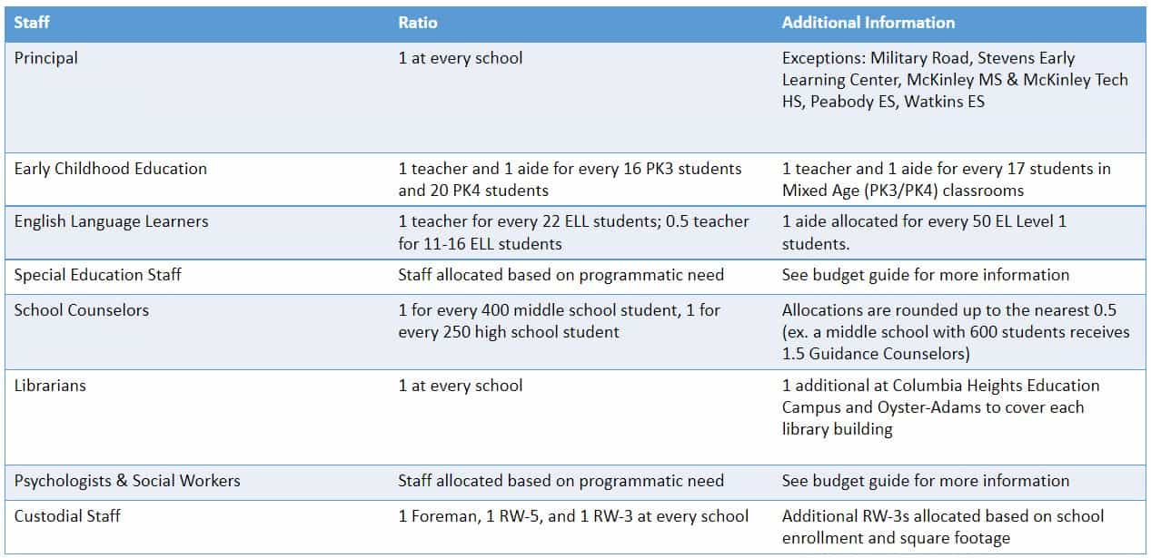

Program Grant Allocations Including At-Risk
Program Grant Allocations
In addition to student- and staff-based dollars, the budget model includes funding allocations for supplemental program grants that are specific to school needs. Schools will receive additional funds to support students with greater needs. One program grant that DCPS schools receive is for at-risk student populations.

Program Grant | School Type​ | Allocation Methodology
Afterschool | Select Title I Schools​  Serving grades K-8​ | Administrative Premium funds are allocated based on the number of seats available in the program. Seats are determined based on prior year after-school enrollment and attendance, demand for additional seats, and the capacity of a school program provider to serve additional students.
At-Risk UPSFF | All Schools | DCPS allocates 90% of the at-risk UPSFF grant amount allocated to the district. Schools receive a per pupil dollar allocation for every at-risk student projected based on the UPSFF allocation to DCPS.
Additional At Risk Concentration | Schools above 40% at-risk | Schools with at least 40% at-risk students projected receive a per pupil amount that is 5% of the UPSFF base amount for each student over 40%.  Schools with at least 70% at-risk student projected receive an additional 5% of the UPSFF base amount for each student over 70%.  This is additive for schools with at least 70% at-risk students projected. In total, they receive 10% of the UPSFF base amount for each student over 70%.
CTE & NAF | Select High Schools | CTE teachers are allocated to high schools so they may maintain programming.  NAF personnel are allocated based on the needs and size of the schools’ NAF academies.
Credit Recovery | Select High Schools | Funding allocations are based on size of school, number of failures and anticipated course recovery needs, and program and funding usage during the prior year.
Dual Language | Select Schools​ | Schools are allocated per pupil dollar amounts based on the number of EL and At-Risk EL students. The amounts are different between “1 way” and “2 way” programs. See budget guide for more information.
Global Studies | Select Schools​ | Global studies schools are allocated 1 Coordinator and $3,000 in non-personnel dollars for programming.
International Baccalaureate (IB) | Select Schools​ | Schools are allocated 1 Coordinator per program and varying amounts of non-personnel dollars for the program depending on their programmatic need for PD, subscriptions etc.
JROTC | Select High Schools | Schools are allocated 2 JROTC instructors to lead programming.
Pool Programming | Select Schools​ | High Schools with pools and Marie Reed are allocated required Aquatic teachers and the funds required for the MOU with DPR as well as $5,000 in supplies.  Schools part of the Grade 3 swim programming are allocated a lump sum of dollars that pays for the cost of transportation to the pools, required aquatics staff, and supplies.
Ninth Grade Academy | Select Title I High Schools​ | Schools are allocated a Ninth Grade Academy Assistant Principal and administrative premium and non-personnel dollars relative to their size to fund the academy.
Reading Specialists (Title Funded) | Select Elementary Schools | CW Harris, Langley, Moten, Patterson, Stanton, and Thomas are allocated one Title I funded Reading Specialist.
Safe & Positive Schools​ | Select Middle and High Schools | Schools who were approved for the Safe and Positive pilot program in SY21-22 will continue to receive this funding. In FY24, it is 7.5% more than the amount it was in FY23.
School Office Support​ | All Schools | All schools receive flexible funding in the amount of the position cost of an administrative aide.
Specialty Payments​ | Select Schools | Brookland (arts),  Banneker, SWS HS, Ellington (Specialty HS)  Coolidge, Bard (Early College Partnership)  McKinley Tech HS
Title I Schoolwide & Parental Involvement | Title I Schools | Title I schools receive a per pupil amount of funding based on their eligibility percentage (schoolwide) and projected enrollment (Title I parental involvement). Title I schools do receive Title II dollars, but it is combined with Title I as part of their Schoolwide allocation. The per pupil is determined based on the overall expected grant award.
Title II​ | Non-Title I Schools | Title II funds are allocated to non-Title I schools as a per pupil amount based on projected enrollment. The per pupil is determined based on the overall expected grant award.
Total Non-Personnel Services Funds | All Schools | Schools receive a per pupil dollar amount for every student in the projected enrollment. From this allocation, the school’s contribution to the library MOU is locked and individual overtime and administrative premium budgets are pre-budgeted.
Twilight​ (Title Funded) | Select Title I High Schools​ | Schools are allocated administrative premium to pay teachers to staff the program. The exact amount of funding available to each school is determined based on past funding usage and projected student need. Students may enroll in Twilight sessions at another school that is not their home school.

Stability Funding
The Basics
It is important that our budget model effectively supports schools of all sizes. The funding model was designed to provide schools with year-over-year stability funds, with safety net checks and stabilization dollars that will protect school budgets from the impact of fluctuating enrollment and ensure that schools can afford a baseline level of general education services with their student-based funds.
If a school receives any of the Stability Funding Allocations, they will be displayed individually on the Initial Allocation worksheet.
Stability Funding In The DCPS School Funding Model
The funding model provides stability funding to schools in two distinct ways. Note that in any given budget year, there could be additional one-time stability funds provided to schools outside of the Funding Model. Those are not captured here.

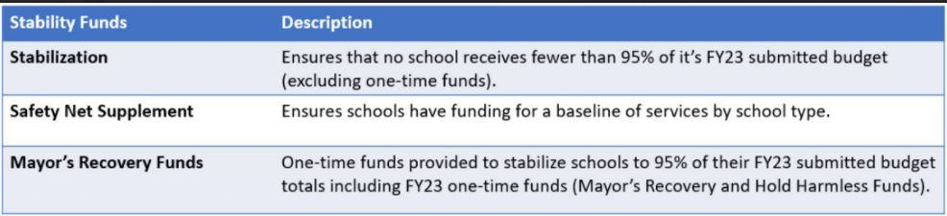
Stabilization
Schools receive stabilization funding to maintain an initial allocation amount that is no less than 95% of their prior year submitted budget. In FY24, stabilization is calculated using schools’ FY24 formulaic budget and comparing it to their FY23 submitted budget (March 2022) excluding any one-time funding. These funds are fully flexible and can be used at the principals’ discretion to budget for staff and programming at the school.
Safety Net Supplement
The safety net supplement is provided to schools when the student-based funds do not generate enough dollars to provide a baseline of services by school type. The model calculates the cost of the baseline services at every school based on the individual school’s enrollment and school type. If the amount of student-based funding generated by a school is not enough to afford the safety net, then a school is allocated a “safety net supplement” which is the amount of funding a school would need to afford their safety net. Safety net funds are fully flexible.
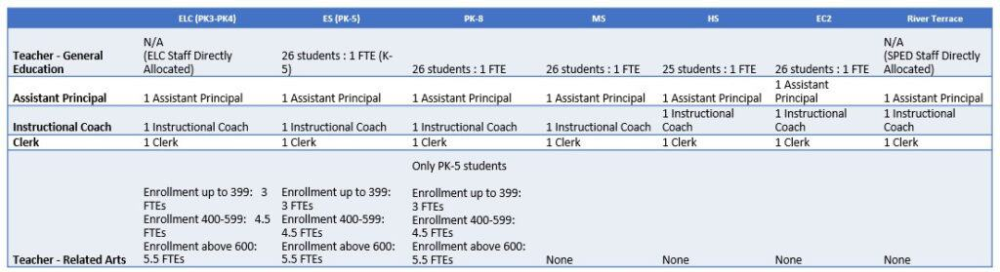

What is it?
- An assurance that student-based funds (Mark and Ella) can afford a baseline level of services for all schools based on school type/size
- Schools whose Student based funds do not generate enough funds to pay for these items will receive a stability fund allocation “safety net supplement” which is the amount needed to afford their safety net.
What is it not?
- A direct allocation of items
- A guarantee that schools are budgeting these positions in this manner (where program requirements is important)
- The only way schools receive funding. Schools can budget for these and more positions using other funding streams

Mayor’s Recovery Funds
FY24 will mark the second year of Mayor’s Recovery Funds as committed to by Mayor Muriel Bowser. In FY24, Mayor’s Recovery Funds will be used to stabilize schools at 95% of their FY23 funding level including one-time funds. DCPS typically stabilizes schools to their previous fiscal year submitted budget not including any one-time funds provided outside of the school funding model formula. In FY23, some schools received Mayor’s Recovery Funds to provide stability during the pandemic. These funds were designed to help schools maximize buying power by allowing them to afford similar levels of staff and programming from FY22 and are to be budgeted at the principals’ discretion. This is a one-time allocation in FY24.

Average Position Cost
DCPS budgets for all school-based staff based on the average salary cost of the position. For the portion of resources allocated in a staffing model, DCPS provides the school the exact amount of funding required to purchase the position (average salary, benefits, and holdouts). The actual staff member who is hired may receive a salary that is greater than or less than the average, based on their qualifications. Using average salaries protects schools against fluctuations due to staff changes and maintains schools’ ability to hire teachers based on quality.
Calculating Salary and Benefits
DCPS determines the average salary collaboratively with the Office of the Chief Financial Officer based on an analysis of payroll data. Typically, the average salary increases every year due to cost of living increases and rising healthcare costs, among other reasons. The benefits rate is determined through a similar process and each year, it is budgeted at approximately 15-17% of the base salary.
Administrative Add-Ons
In addition to salary and benefits, DCPS adds the costs of certain expenses related to each union (e.g., the Washington Teachers’ Union, or WTU) and/or position type to the average salary and benefits. These additional costs are called “hold outs” or “add-ons.” For example, each teacher receives a $200 teacher supply card to purchase classroom supplies as part of the WTU contract. This $200 is added on top of the salary and benefits of every WTU position that is budgeted. Other examples of these add-ons include the costs of employee fingerprinting, ensuring compliance with disability accommodations required by the Americans with Disabilities Act (ADA), and cost of IMPACT teacher performance bonuses. The total costs are distributed across each position in a “per unit cost” during the budget development process and combined into one “add-on,” which is combined with average salary and benefits to determine the total average cost of the position. The total “hold out” cost will vary based on position types since the expenses that they pay for can vary by position types. The total hold out budget is centrally managed.

FY24 Average Position Costs
FY24 WTU Add-Ons and Average Teacher Position Cost
Description | Line Item | FY24 Cost per WTU | FY24 Budget
Mutual Consent Excessing Options | Extra Year Option | $58.36 | $316,800
Mutual Consent Excessing Options | Buyout Option | $4.61 | $25,000
IMPACT Bonuses | IMPACT Bonuses | $2,585.50 | $21,925,000
Background Checks | Drug & Alcohol Testing | $26.62 | $225,750
Background Checks | Fingerprinting Screen | $56.66 | $480,500
Background Checks | Fitness for Duty/FMLA Vertification | $2.68 | $22,712
Employee Support | Start-Up Supplies | $200.00 | $1,070,800
Employee Support | ADA Accommodations | $58.60 | $496,950
Employee Support | WTU Tuition Reimbursement | $14.74 | $80,000
Employee Support | International Visas | $4.97 | $27,000
Employee Support | WTU Placements | $363.33 | $1,972,140
Employee Support | Employee Assistance Services | $11.14 | $94,500
Stipends | DINR Bonus | $41.45 | $225,000
Stipends | Department Chair Stipends | $101.33 | $550,000
School-Based Costs | Substitutes | $1,481.39 | $8,041,000
School-Based Costs | Enrollment Reserve | $330.19 | $2,800,000
School-Based Costs | Backfill | $184.23 | $1,000,000
School-Based Costs | New Teacher Pipeline | $46.06 | $250,000
 | Add-ons | $5,572
 | Base Salary | $94,474
 | Salary and Benefits | $109,590 | Benefits Rate = 16.0% of salary

FY24 CSO Add-Ons
Description | FY24 Cost per CSO | FY24 Budget
IMPACT Bonuses | $2,585.50 | $21,925,000
Drug & Alcohol Testing | $26.62 | $225,750
Fingerprinting Screen | $56.66 | $480,500
Fitness for Duty/FMLA Vertification | $2.68 | $22,712
ADA Accommodations | $58.60 | $496,950
Employee Assistance Services | $11.14 | $94,500
Enrollment Reserve | $330.19 | $2,800,000
Professional Development | $73.96 | $50,000
Start-Up Supplies | $200.00 | $153,200
Total Add-ons | $3,345 | $26,248,612

FY24 AFSCME Add-Ons
Description | FY24 Cost per AFSCME | FY24 Budget
IMPACT Bonuses | $2,585.50 | $21,925,000
Drug & Alcohol Testing | $26.62 | $225,750
Fingerprinting Screen | $56.66 | $480,500
Fitness for Duty/FMLA Vertification | $2.68 | $22,712
ADA Accommodations | $58.60 | $496,950
Employee Assistance Services | $11.14 | $94,500
Enrollment Reserve | $330.19 | $2,800,000
Legal Fund | $28.74 | $50,000
Metro Pass | $45.98 | $80,000
Total Add-ons | $3,146 | $26,175,412

FY24 Teamsters Add-Ons
Description | FY24 Cost per Teamster | FY24 Budget
IMPACT Bonuses | $2,585.50 | $21,925,000
Drug & Alcohol Testing | $26.62 | $225,750
Fingerprinting Screen | $56.66 | $480,500
Fitness for Duty/FMLA Vertification | $2.68 | $22,712
ADA Accommodations | $58.60 | $496,950
Employee Assistance Services | $11.14 | $94,500
Enrollment Reserve | $330.19 | $2,800,000
Transportation | $33.00 | $20,000
Shift Differential | $1,479.90 | $896,822
Home Assistance | $82.51 | $50,000
Total Add-ons | $4,667 | $26,985,234

Enrollment Projection Methodology

D.C. Public Schools’ enrollment projections are an estimate of enrollment at each school on October 5th of the subsequent school year. October 5th is the official enrollment audit date set by the Office of the State Superintendent for Education (OSSE). DCPS analyzes past enrollment trends to calculate total enrollment at each school, enrollment of students who receive special education services, and enrollment of students who are English learners.
Grade progression ratio
The analysis of enrollment trends include a ‘grade progression ratio’ (sometimes referred to as a ‘cohort-survival rate’) – a projection calculation commonly used by school districts. The grade progression ratio relies on at least three years of October 5^{th[1]} enrollment to identify the average change in class size from one grade to the next.
In the example below, trends show that this school typically has a larger second grade class compared to its first-grade class. In other words, the second-grade class enrolls more than 100% of their first-grade class. This makes the average grade progression ratio more than 100
In the example below, trends show that this school typically has a larger second grade class compared to its first-grade class. In other words, the second-grade class enrolls more than 100% of their first-grade class. This makes the average cohort survival rate more than 100%.
[1] Due to October 5th falling on a Saturday in 2019, the actual date of the audit was October 7th.
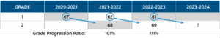
The rising enrollment is then averaged to account for fluctuation in each year, and multiplied against the rising second grade class (current first grade class):
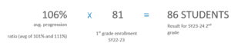
The result for this second-grade class is 86 students. When the result is a fraction, rounding up or down is determined by looking to the most immediate years of enrollment. In the previous school year, this school has gained a few students throughout the year. In this case, we would round up to account for the possibility that the grade gains a student.
Calculating enrollment projections relies on enrollment of past years. Knowing the past few years of enrollment were heavily impacted by COVID-19, DCPS adjusted the enrollment projections process in two specific ways. In school-grades in which there was significant fluctuation in enrollment over the past few years, DCPS calculated average grade progression ratios with the year of the lowest grade progression rate omitted. At any school where the SY22-23 K class is smaller than previous years, we increased the expected grade progression ratio into 1st grade by 1.5%. This was done to avoid under-projecting grade 1 for SY23-24.

In Kindergarten, 6th, and 9th grades, the process combines three factors to build a projection.
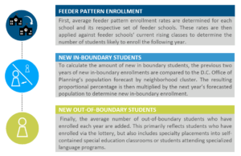
Then, all three factors are combined (Feeder Pattern Enrollment, New In-Boundary Enrollment, and New Out-of-Boundary Enrollment) to make a final projection. The final projection is compared to historical school trends to see if the class size reflects recent enrollment trends. Where a Kindergarten, 6th, or 9th grade projection significantly differs from a school’s recent trends, the School Planning Team reviews all three prior pieces to understand why.

Early Childhood Projections
Early Childhood Education (ECE) classes are projected based on the number and types of classrooms each school offers. Each pre-kindergarten (PK) classroom is generally projected to reach its seat capacity, except for a few seats reserved for children with developmental needs who are placed through DCPS’ Early Stages office.
In response to COVID-19, this year DCPS assumed that additional PK3 & 4 students would likely return as families become more comfortable sending young children to school. In most cases this held Early Childhood Enrollment steady to pre-COVID-19 numbers.
ECE class sizes are regulated by D.C. Municipal Regulations and are specifically outlined in the circles below, along with our projection approach in each grey box:
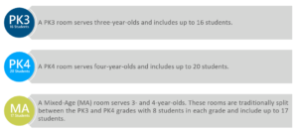

Enrollment Projection Principal Review And Adjustment
Once the projections for the total school-wide enrollment, special education, English learner, and early childhood have been calculated, each school’s enrollment projection is reviewed to determine if its grade level growth aligns with contemporary trends. If a contemporary trend suggests a change in the enrollment growth pattern at a school that is not captured in the projection, then the projection may be adjusted to reflect the change in trends.
Specific programming changes are also reviewed at this time. The changes may include grade configuration changes, new or expanded programming, and temporary or permanent location changes, along with other place-based circumstances that may result in a smaller or larger class size by grade for the following school year.
Finally, each school’s enrollment projection is shared with its respective principal, Local School Advisory Team (LSAT), and instructional superintendent. Principals review and can propose changes to their projections. Any proposed change requires a written rationale, and all proposals are reviewed and considered. Upon review, a final decision is made to either accept or reject (in full or in part) a principal’s proposed changes. A rationale is provided to each principal based on their enrollment request. Once adjustments are finalized, final projections are shared with principals.

